Student Reports on Banned Books

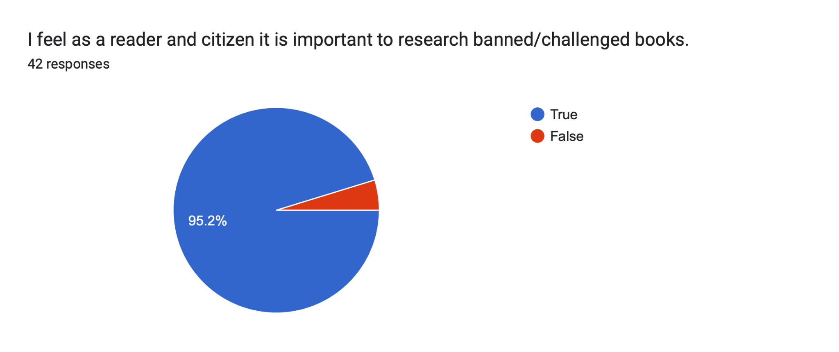

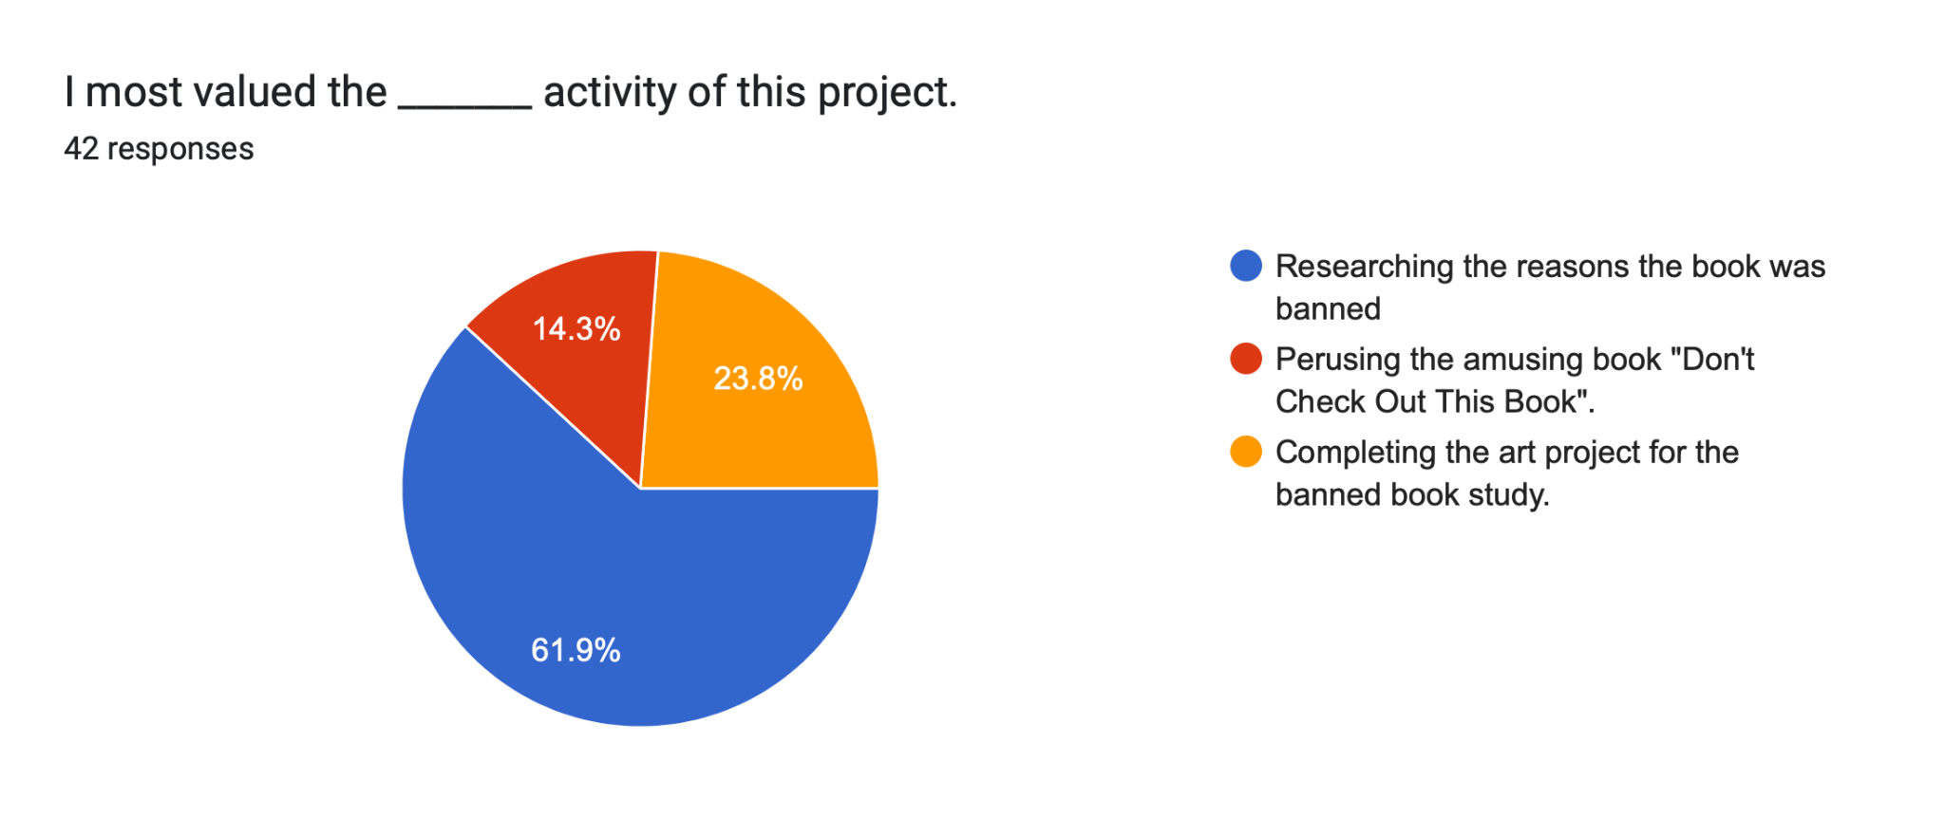

Hear From Students
Is it important to read banned books?

It is important to read banned books in order to maintain freedom of speech and spreading of ideas. It can answer questions for kids who are embarrassed to ask.
- Danyal Choudhry 650

Well, it depends if you are a reader and would like to research banned books then go ahead. You need to learn if you want to know more about banned books
- Albert Rodriguez 650

Because you will do 2 things: 1 wonder why it's banned and write or talk about it or 2 why it is banned and read it. I think these 2 options are what we can do. ​​
- Aldo Ramirez 650

I feel that it’s important as it shows us how books are discriminated against and what we can do to prevent or help stop it. It increases thoughts towards books and how we should appreciate them and what amazing things they hold.
- Samirjon Karimov 650

I think you should research your banned book because it can give you information on why it got banned. You’ll know a lot of information about the banned book that you’ll know just enough to write about your banned book. A green dot collection of books you cannot put down without completing is needed because you’ll need to do research about the banned book.
- Victoria Figueroa 660

The reason why I believe that as a reader and citizen it is important to research banned/challenged books is so that we can learn why the book got banned and understand books more. It’s important to research challenged books as well so we can understand it and learn about it.
- Momina Tanveer 660

I think this because, if you don’t research about banned books and you're a reader, then you're missing out on all these books that are banned. I also think banned books help readers grow. A green dot collection of books you can’t put down without completing is needed because, this means you're really interested in the book and you might get more into books.
- Sania Hossain 660

The reason why I think that it is important to research banned books is that we should know why the book is banned. Also we need to know the name of the book and what it’s about. In addition we should research the author and all other books they wrote. Basically researching banned books can help you learn more about them. It makes children read more and increase both reading skills and mental health.
- Mashiat Anisha 660

I feel like books being banned is very important and more people need to know about books being banned. People are banning books and taking the chance of reading wonderful books away from other people like children. I think it is needed because a lot of people like books because some read some for fun and some read for knowledge. I think people recommending books and sharing them is nice because there are amazing books out there. People now finding out about them is good because people are reading more
- Bradley Boateng 670

I think it's important to research banned books because I want to learn why it was a challenged book and what wasn't right in it I think people should read green dot books because people should know what it was about and see if they like it or not because other people have chosen too.
- Anna Manzanal 670

I think it is good to research banned books that are challenged because you never know if it was a good book to read and you should never judge a book by its cover. It will make more understanding of the book.
- Kyara Arroyo Salazar 670

It is important to do research on banned/challenged books because you can learn more about different books and the public's opinion and why the books were challenged. It's supposed to be entertaining to kids and interesting that you can not put it down.
- Ingrid Meza Dorado 670

